- Mohamedahmed01097@gmail.com
2023
Model-Based Development : Simulink Module
MAAM Subtitle
- M. A. Abdellah

Introduction

Simulink Basics Module

Simulink Environment Overview
- Opening Simulink: Steps to launch and begin modeling.
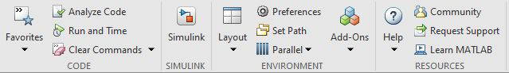
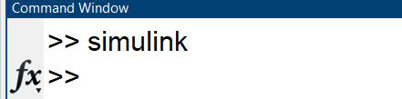
- Simulation Toolbar: Tools to configure and run simulations.
 | The zoom tool in Simulink allows you to change the view of your model by adjusting the zoom level.
 | The "Fit to View" feature in Simulink is a tool that allows you to adjust the model's display
 | The tool provides a clear and organized display of each block's sample time in your model.
 | an annotation is a text-based or graphical element that you can add to your model or subsystem
 | To insert image
 | To Insert Area

- Library Browser: Locate blocks for modeling.
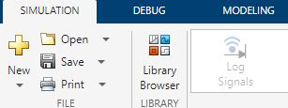
- Annotations and Image Insertion: Enhance models with text and visuals​.

Adding and Connecting Blocks
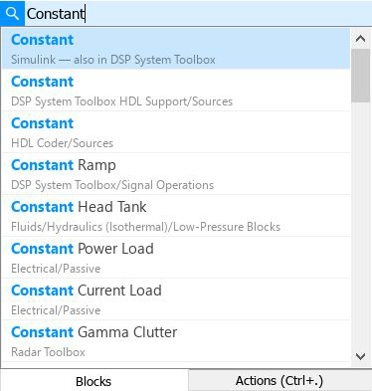
- Open Simulink, create or open a model.
- Drag blocks from the Library Browser into the workspace.
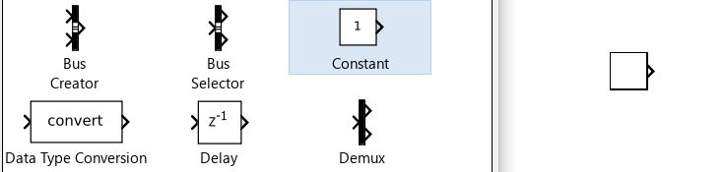
- Browse for Blocks.
- Use lines to connect input/output ports.
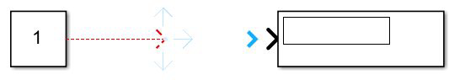
- Configure Block Parameters.
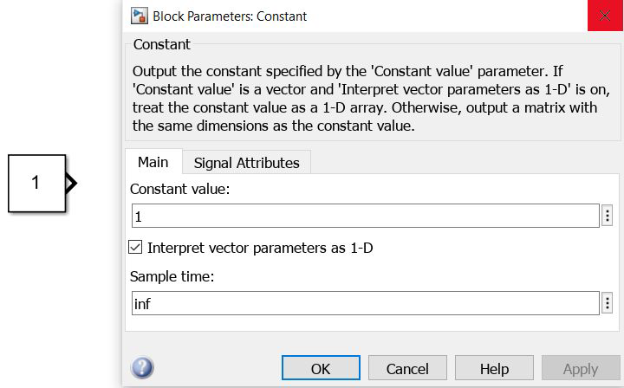
- Save the model after configuring parameters​ and Run the Simulation.
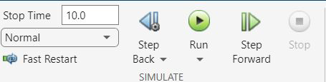

Common Blocks and Examples

Constant Block | generate a constant signal or value.  Inject fixed values into models. | 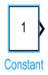
Sum Block | perform mathematical operations, particularly addition and subtraction. | 
Product Block | multiplication operations in a model. | 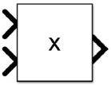
Gain Block | scale or amplify input signals by a constant factor.  adjust the magnitude or amplitude of signals. | 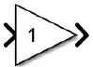
Switch Block | allows you to select between two input signals based on a control signal. | 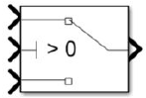
Mux Block | combine multiple input signals into a single output signal. | 
DeMux Block | separate a single input signal into multiple output signals. | 
Display Block | type of block that is typically not used for modeling the dynamics of a system but rather for visualization and monitoring purposes. | 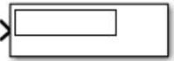
Step Block | generate a step function as an input signal for a dynamic system.  “Time of Step, Initial Value, Final Value” | 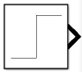
Sine wave Block | generate a sine wave signal with specific parameters.  Freq (rad/sec) = 2 pi W; | 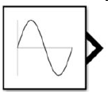
Ramp Block | generate a continuous ramp signal as an input for dynamic systems.  “Slope, Initial output” | 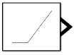
Subsystem Block | powerful organizational and modular building block used to structure and simplify complex models. | 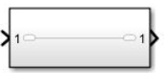
Data Type Conversion | convert signals from one data type to another. | 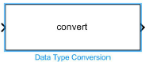
Compare To Zero  Compare to Constant | conditional checks and logical operations where the comparison is with Constat. | 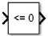
Logical Operator block | perform logical operations on signals. These operators evaluate conditions and produce logical (Boolean) outcomes. | 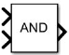
Bitwise Operator block | perform bitwise operations on integer signals. | 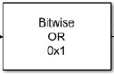
Unit Delay | one-sample delay in a discrete-time system. Witch helps capture the dynamic behavior of systems and is fundamental for building discrete-time models. | 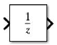
Abs block | used to compute the absolute value of an input signal. | 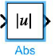
MinMax block | compute the minimum and maximum values of two input signals. | 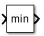
PWM block | generate a pulse-width modulated signal. | 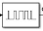
Saturation block | limit the range of an input signal within a specified upper and lower bound | 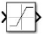
Goto and from block | create signal connections between different parts of a model. | 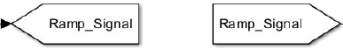
Merge Block | combine multiple input signals into a single output signal. | 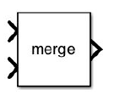
1D Lookup Table | mapping input values to corresponding output values. | 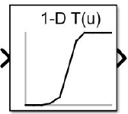

Simulink Basics Module

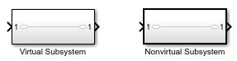
Subsystems and Solvers
- Subsystem Types:
  - Virtual: For graphical hierarchy only.
  - Non-virtual: Execute as atomic units.
- Creating Subsystems: Insert blocks or convert existing structures.
  - Grouping blocks into subsystems helps organize complex models by reducing visible blocks.
  - Functionally related blocks grouped in subsystems enhance model coherence and clarity.
  - Each subsystem defines clear input and output interfaces, supporting modular design and system integration.

Solvers in Simulink
- Fixed-Step Solvers: Use constant time steps for predictable systems.
- Variable-Step Solvers: Dynamically adjust steps for accuracy in varying dynamics​.

Code Generation
- Translate models into C code for embedded systems using Embedded Coder.
- Key benefits: Reliable and efficient deployment of real-time applications​.
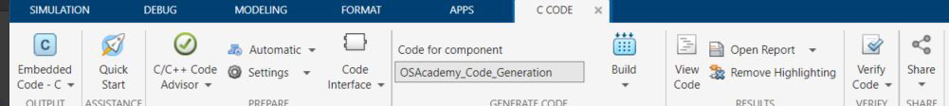

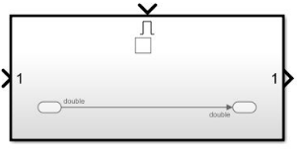
Advanced Subsystems
- Enabled Subsystems
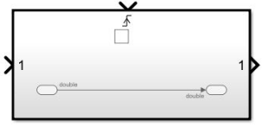
  - Triggered by an external signal transitioning from negative to positive.
- Triggered Subsystems
  - Execute based on a signal crossing a threshold or detecting an event.
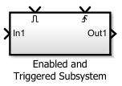
- Enabled and Triggered Subsystems
  - Combine enable and trigger conditions for execution.
- If Action and Switch Case Subsystems
  - Execute based on logical expressions or case conditions.
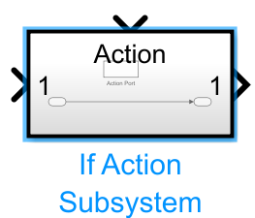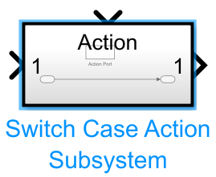
- Function Call Subsystems
  - Execute on receiving function-call events from sources like Stateflow or MATLAB functions​.
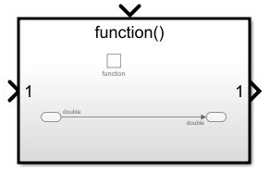

Masking Fundamentals
- Purpose: Create custom interfaces for blocks with tailored parameter dialogs.
- Use Cases:
  - Encapsulate complex logic for better usability.
  - Allow selective parameterization of internal components.
  - Display intuitive icons​.

Simulink keyboard shortcuts

https://www.mathworks.com/help/simulink/ug/summary-of-mouse-and-keyboard-actions.html
Perform File and Clipboard Actions
Undo  Redo  Cut  Copy  Past  Find | Ctrl + Z  Ctrl + Y  Ctrl + X  Ctrl + C  Ctrl + V  Ctrl + F
Open Simulink Model  Create a New Model  Save Model  Save current referenced model  Close Current Model  Close All Models  Quit MATLAB | Ctrl + O  Ctrl + N  Ctrl + S  Ctrl + Shift + S  Ctrl + W  Ctrl + Shift + W  Ctrl + Q

Format Block Diagram
Create subsystem from selection  Refresh Model blocks  Flip blocks  Rotate blocks clockwise | Ctrl + G  Ctrl + K  Ctrl + I  Ctrl + R
Create and Edit Mask of a Block  Look under the Mask  Navigate to Top-Level Diagram | Ctrl + M  Ctrl + U  Ctrl + Shift + U
Comment Out a Block  Uncomment a Block  Automatically arrange model | Ctrl + Shift + C  Ctrl + Shift + X  Ctrl + Shift + A
Run the current line or section | Shift + Enter

Navigate Model
Open the Model Explorer  Open or hide the Property Inspector  Open Simulink Library Browser  Open Model Data Editor | Ctrl + H  Ctrl + Shift + I  Ctrl + Shift + L  Ctrl + Shift + E

Simulate, Update, and Generate Code for Models
Start simulation | Ctrl + T or F5
Stop simulation | Ctrl + Shift + T
Update model | Ctrl + D
Open Configuration Parameters dialog box | Ctrl + E
Build model (for code generation) | Ctrl + B

Contents
1) Introduction 1
a) Simulink Basics Module 1
i) Simulink Environment Overview 1
ii) Adding and Connecting Blocks 2
iii) Common Blocks and Examples 3
b) Simulink Basics Module 4
i) Subsystems and Solvers 4
ii) Solvers in Simulink 4
iii) Code Generation 4
iv) Advanced Subsystems 5
v) Masking Fundamentals 5
2) Simulink keyboard shortcuts 6
3) Contents 7

